**DevOps Lifecycle – It is all about “continuity”**

There is a total of seven phases in the DevOps lifecycle – Continuous development, continuous integration, continuous testing, continuous delivery, continuous feedback, continuous deployment, and continuous operations. Let us discuss each of the DevOps lifecycle phases below.

#### ****1). Continuous Development****

**(Plan application objectives and Code the requirements)**

In the first phase of DevOps lifecycle, you should plan your application objectives that must be delivered to the customer.

Once you are sure of application objectives, start with the project development. It includes activities like code generation and putting the same to the next phase. As DevOps follows the continuous development approach, so work may carry out on the existing code by using continuous feedback in the development and operation scheme.

#### ****2). Continuous Integration****

**(Plan Tests and Build the product)**

The continuous integration process automatically starts after development. It includes several steps like the planning of tests that will be carried out in the next phase, understanding the code to produce the desired outcome as needed in the initial project documentation. Continuous integration is the seamless process in DevOps that leads to the next phase in an efficient manner.

OR

[Continuous integration](https://en.wikipedia.org/wiki/Continuous_integration) is the practice implying app development teams to frequently integrate new or changed code into a shared code repository. Then, each check-in is verified by an automated build, enabling developers to identify and correct errors immediately.

#### ****3). Continuous Testing****

**(Verify the product for actual usage in a live environment)**

Testing process checks the actual use of an application in the DevOps. Beta testers produce results while still ensure that application can have its intended use in a live environment. The testing process gives more information about different aspects of an application that in turn is sent to the development process to improve the application.

OR

[Continuous testing](https://en.wikipedia.org/wiki/Continuous_testing) in DevOps is an essential part of building software solutions, that represents the process of executing automated tests enabling to provide continuous feedback on business risks in the latest application build.

Since testing occurs continuously, app development teams can fix bugs on time and prevent defects from progressing to the next step of the [software development lifecycle (SDLC](https://smartym.pro/blog/software-development-life-cycle/)

#### 

#### ****4). Continuous Monitoring****

**(Monitor the product output and find the problem areas)**

The monitoring phase is the operational phase in DevOps where key information about application usage is recorded and carefully processed to find out trends and identify the problem areas. It enhances the operational efficiencies of a software product that may occur in the form of documents or produce massive data about application parameters when the application is in a continuous use position.

OR

Continuous monitoring is the practice, used for defining risks and weaknesses in the application. The product is under constant monitoring which allows engineers to correct errors on time and make required improvements. The result is high-quality software that meets customer’s needs and expectations.

#### ****5). Continuous Feedback****

**(Improvise the current product and helps to release new versions quickly)**

The application performance is improved consistently by analyzing the final outcome of the product. The continuous feedback is an important phase of the software application where customer feedback is a big asset to improve the working of the current software product and release new versions quickly based on the response.

#### ****6). Continuous Deployment****

**(Ensures product is deployed with maximum accuracy)**

The deployment process is performed in such a way that any changes made in the code should not affect the functioning of high traffic website.

OR

Continuous delivery is the development practice of running every code change through automated tests, creating successful application builds, and promoting them up to production stage using automated deploys. Though the practice isn’t easy, it helps create, test, and deploy apps more quickly and with minimized risks.

#### ****7). Continuous operations****

**(Automate release process with shorter development cycles)**

All DevOps operations are based on continuity with complete automation of the release process and allow organizations to accelerate the overall time to market on an ongoing basis.

It is clear from the discussion that continuity is the critical factor in DevOps removing the abundant steps that often distract the development, take it longer to detect issues, and producing a better version of the product after several months. With DevOps, you can make any software product more efficient and increase the overall count of interested customers in your product. Let us see how businesses are benefitted through DevOps deployment.

## DevOps Lifecycle

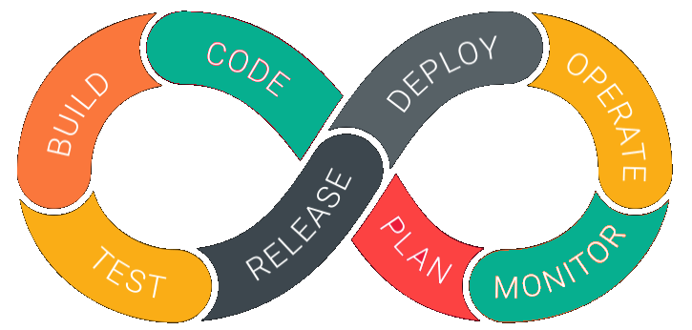

DevOps is deep integration between development and operations. Understanding DevOps is not possible without knowing DevOps lifecycle.

Here is a brief information about the Continuous DevOps life-cycle:

**1. Development**

In this DevOps stage the development of software takes place constantly. In this phase, the entire development process is separated into small development cycles. This benefits DevOps team to speed up software development and delivery process.

**2. Testing**

QA team use tools like Selenium to identify and fix bugs in the new piece of code.

**3. Integration**

In this stage, new functionality is integrated with the prevailing code, and testing takes place. Continuous development is only possible due to continuous integration and testing.

**4. Deployment**

In this phase, the deployment process takes place continuously. It is performed in such a manner that any changes made any time in the code, should not affect the functioning of high traffic website.

**5. Monitoring**

In this phase, operation team will take care of the inappropriate system behavior or bugs which are found in production.